# 1

* All integer from 1 to 9 are fine, giving result are “one” to “nine” as expected
* Numbers outside the range 1 to 9 does not give any result in the console
* The same thing happened if “-5” is entered, this number is not in 1 to 9 range
* If I type a letter, this message (*) appears in my code:  
  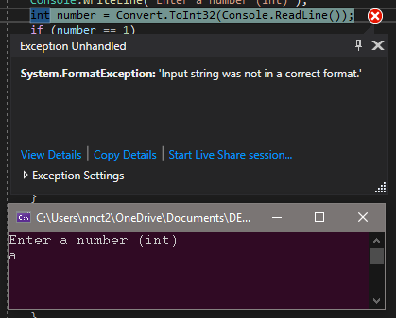
* To handle this error with a message, I use try-catch block like this to add a message and details:   
  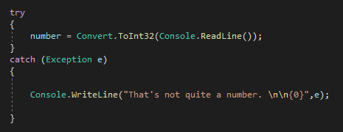

# 2

* All the integer from 1 to 9 brings the expected result.
* The integers outside this range, including negative integers brings this message:   
  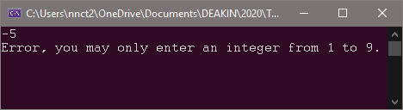
* The same message as above (*) appears when I put a letter in the terminal.
* Handling with try-catch block:  
  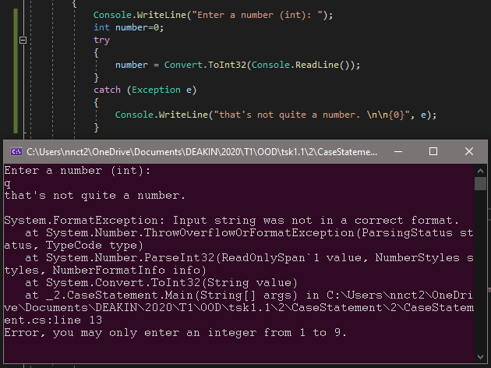

# 3

int number = 50;

if (number == 50) ; {

Console.WriteLine(“Number is 50”);

}

* There should be no “;” after the condition of the “if” statement

int number = 60;

if (number >== 50 and number <== 100) {

Console.WriteLine(“Number is more than or equal to 50 and less than or equal to 100”);

}

* The operators for “less than or equal” and “greater than or equal” are “<=” and “>=”

public class Score {

public static void main(String[] args) {

double score = 40;

if score > 40{

Console.WriteLine("You passed the exam!");

} else score < 40{

Console.WriteLine("You failed the exam!");

}

}

}

* “if (score >40)” and “else if (score <40)”

Switch (n) {

case 1: Console.WriteLine(“The number is 1”); ***

case 2: Console.WriteLine (“The number is 2”); break;

default: Console.WriteLine (“The number is not 1 or 2”);

break;

}

* Did not initial the variable “n”, lowercase for “Swtich”, no “break;” after “case 1”.

switch (n) {

Case 1: Console.WriteLine (“A”); break;

case2: Console.WriteLine (“B”); break;

Default: Console.WriteLine (“C”); break;

}

* Lowercase “Case” and “Default”, did not initial the variable “n”.

# 4

1. Proceed with caution
2. You win   
   the prize.
3. You lose  
   the prize.

# 5